**Liquid Refreshment**

1. Coffee
   1. Coffee beans



* 1. Coffee drinks

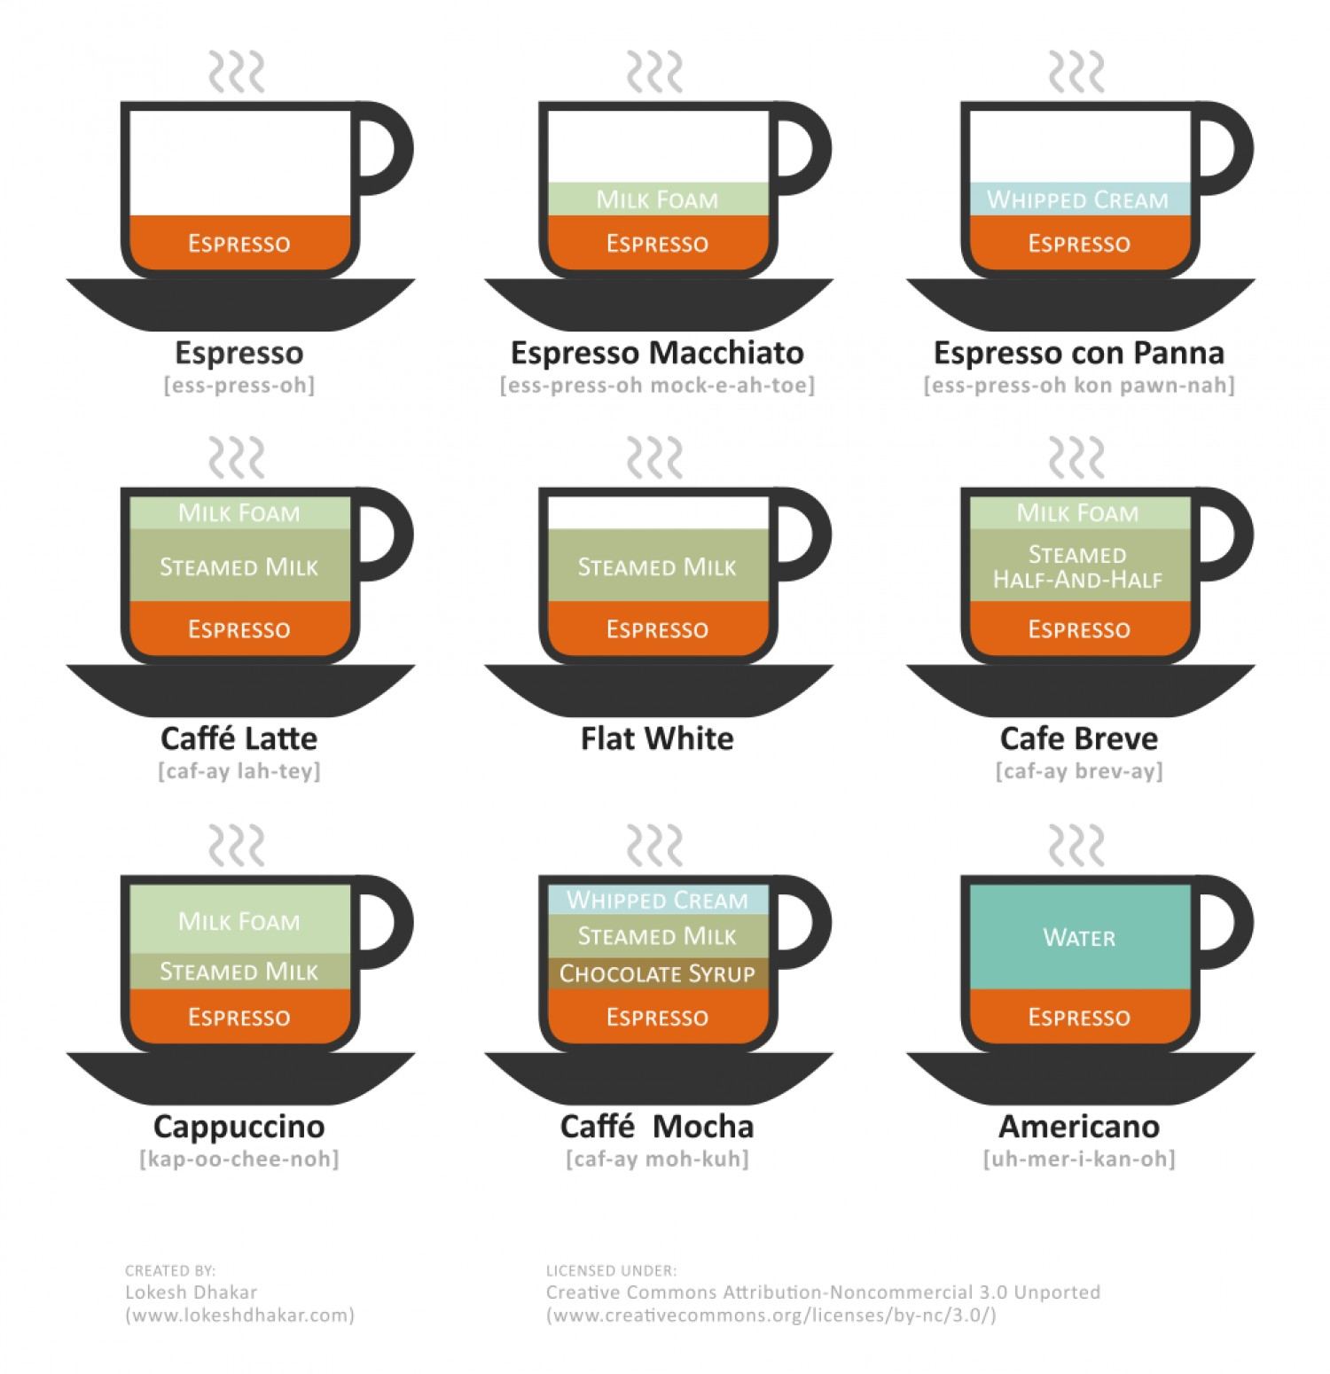

* 1. Caffeine content

1. Tea
   1. Types of tea leaves

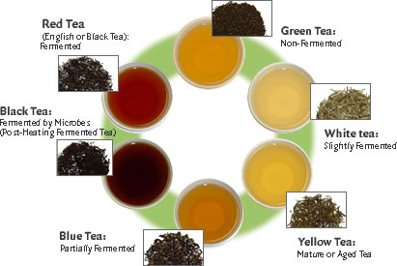

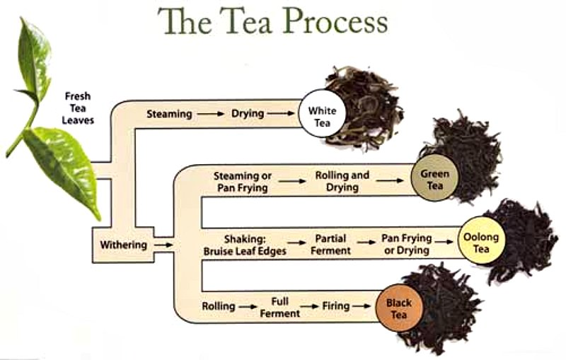

* 1. Brewing tea

