Practice Problems:
N = 6.02 x 10²³ R = 0.08206 L•atm/mol•K 1atm = 760 mmHg = 760 torr
T(K) = T(ºC) + 273.15ºC 1L•atm = 101.325 J T(ºF) = 9/5(ºC) + 32ºF
1. What volume (in mL) will a sample of F2 gas occupy in a syringe at 5.5 atm, if the F2 has a volume of 25.0 mL at 1.2 atm?

2. To what volume will a sample of gas expand if it is heated from 50.0°Cand 2.33 L to 500.0°C?

3. A syringe initially holds a sample of gas with a volume of 285 mL at 355 K and 1.88 atm. To what temperature must the gas in the syringe be heated/cooled in order to have a volume of 435 mL at 2.50 atm?

4. What pressure will 14.0 g of CO exert in a 3.5 L container at 75°C?
5. Using the graph below, which of the gases in the graph below has the largest molar mass?

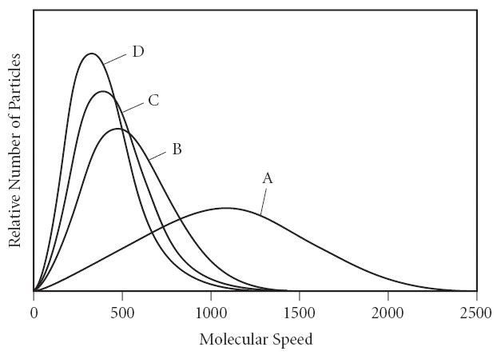
A) A
B) B
C) C
D) D
E) There is not enough information to determine.

6. The density of a gas is 1.43 g/mole at STP. What is the gas?
A) Cl2
B) S
C) O2
D) Ne

7. A mixture of He, Ne and Ar has a pressure of 7.85 atm. If the Ne has a mole fraction of 0.47 and Ar has a mole fraction of 0.23, what is the pressure of He?

8. Determine the volume of O2 (at STP) formed when 50.0 g of KClO3 decomposes according to the following reaction. The molar mass for KClO3 is 122.55 g/mol.

2 KClO3(s) → 2 KCl(s) + 3 O2(g)

9. Which of the following statements is true?
A) At a given temperature, lighter gas particles travel more slowly than heavier gas particles.
B) The smaller a gas particle, the slower it will effuse
C) The higher the temperature, the lower the average kinetic energy of the sample.
D) At low temperatures, intermolecular forces become important and the pressure of a gas will be lower than predicted by the ideal gas law.
E) None of the above statements are true.

10. Which of the following substances (with specific heat capacity provided) would show the greatest temperature change upon absorbing 100.0 J of heat?
A) 10.0 g Ag, CAg = 0.235 J/g°C
B) 10.0 g H2O, CH2O = 4.18 J/g°C
C) 10.0 g ethanol, Cethanol = 2.42 J/g°C
D) 10.0 g Fe, CFe = 0.449 J/g°C
E) 10.0 g Au, CAu = 0.128 J/g°C

11. Calculate the amount of heat (in kJ) required to raise the temperature of a 79.0 g sample of ethanol from 298.0 K to 385.0 K. The specific heat capacity of ethanol is 2.42 J/g°C.

12. Fructose is a sugar commonly found in fruit. A sample of fructose, C₆H₁₂O₆, weighing 4.50g is burned in a bomb calorimeter. The heat capacity of the calorimeter is 2.115 X 10⁴ J/°C. The temperature in the calorimeter rises from 23.49 °C to 27.71°C.
a. What is the q of the calorimeter?
b. what is the q when 4.50 g of fructose is burned?
c. what is the q for the combustion of one mole of fructose?
13. According to the following reaction, how much energy is required to decompose 55.0 kg of Fe3O4? The molar mass of Fe3O4 is 231.55 g/mol.

Fe3O4(s) → 3 Fe(s) + 2 O2(g) ΔH°rxn = +1118 kJ

14. Use the standard reaction enthalpies given below to determine ΔH°rxn for the following reaction:

2 S(s) + 3 O2(g) → 2SO3(g) ΔH°rxn = ?

Given:
SO2(g) → S(s) + O2(g) ΔH°rxn = +296.8 kJ
2 SO2(g) + O2(g) → 2 SO3(g) ΔH°rxn = -197.8 kJ

15. Use the information provided to determine ΔH°rxn for the following reaction:

ΔH°f (kJ/mol) 3 Fe2O3(s) + CO(g) → 2 Fe3O4(s) + CO2(g) ΔH°rxn = ?
Fe2O3(s) -824
Fe3O4(s) -1118
CO(g) -111
CO2(g) -394

Answers

- 5.5 mL
- 5.58L
- 720.5 K
- 4.08 atm
- D
- C
- 2.36 atm
- 13.7 L
- D
- E
- 16.6 kJ
- a. 89.3 kJ
b. -89.3 kJ
c. -3.57 x 10³ kJ
- 2.66 x 10⁵ kJ
- -791.4 kJ
- -47 kJ

