09/17/10 Name_______________________________
Pledge:
When you have completed the exam, please consider the following:
I affirm that I have neither committed nor witnessed a violation of academic integrity in the completion of this portion of the exam.
Signed______________________________
Part I (45) ______________
Part II (15) ______________
Part III (30) ______________
Part IV(10) ______________
Total (100) ______________

PART I. Multiple Choice (45 Points)

- Which of these characteristics does NOT describe the β sheet?
A. Parallel β sheets containing fewer than two chains are the most common.
B. β sheets hydrogen bonding requirements are met by bonding between chains.
C. There are two forms, parallel and anti-parallel.
D. The sheets contain as few as two and as many as 22 polypeptide chains.
E. Side chains are located both above and below the sheet.

- The structure of normal adult hemoglobin can be described as
A. a tetramer composed of four myoglobin molecules.
B. a tetramer composed of two α and two β subunits
C. a tetramer composed of 8 α helices.
D. a tetramer composed of two α₂ and two γ₂ dimers.
E. None of these accurately describe hemoglobin.

- Myoglobin’s secondary structure is primarily composed of ______________.
A. parallel β-sheets
B. antiparallel β -sheets
C. α-bends
D. α-helices
E. β-helices

- What is hydronium concentration of urine at pH = 5.5?
A. 3.16 X 10⁵ M
B. 3.16 X 10⁻⁵ M
C. 3.16 X 10⁻⁹ M
D. 3.16 X 10⁹ M
E. none of the above

- Name three amino acids that are charged at a neutral pH.
- lys, arg, and pro
- his, arg, and cys
- cys, arg, and met
- lys, arg, and asp
- arg, glu, and his

- 2-3 Bisphosphoglycerate
A. binds in the central cavity in the T-form of hemoglobin.
B. preferentially binds to deoxyhemoglobin and stabilizes it.
C. is present in fetal red blood cells.
D. None of the above
E. All of the above

- The configuration of most α-carbon atoms of amino acids linked in a peptide bond is
A. cis
B. circular
C. parallel
D. trans
E. perpendicular

- If a particular reaction has a negative ΔG, is it likely to occur?
A. Not unless energy is added to the system.
B. Yes, if it is coupled to another reaction.
C. Yes, it is spontaneous.
D. No, it will never occur.
E. Yes, if it takes place within a constrained area.

- The type of structure to which α-helices, β sheets, and turns are referred.
A. Primary structure
B. Secondary structure
C. Tertiary structure
D. Quaternary structure
E. None of the above

- Which of the following amino acid residues would most likely be buried in the interior of a water soluble, globular protein?
A. Asparagine
B. Serine
C. Phenylalanine
D. Lysine
E. Glutamine

- Proteins often have regions that show specific, coherent patterns of folding or function. These regions are called:
- domains.
- oligomers.
- peptides.
- sites.
- subunits.

- This amino acid residue often prevents the formation of an α helix because its side chain contains a unique ring structure that restricts bond rotations.
- Aspartate
- Serine
- Proline
- Histidine
- Glycine

- Which one of these characteristics is NOT true for the α helix?
A) There are 3.6 amino acids per turn.
B) There is a requirement for glycine every third amino acid residue.
C) A hydrogen bond forms between the carbonyl oxygen of the nth amino acid residue and the —NH group of the (n + 4)th amino acid residue.
D) Proline is typically not found in the  helix.
E) It is right-handed.

- Amphiphilic molecules:
A) have both oxidizing and reducing groups.
B) are micelles.
C) have chromophores in two different wavelength regions.
D) have both acidic and basic groups.
E) have both hydrophilic and hydrophobic groups.

- Which of the following are able to form biopolymers?
A) carbohydrates
B) amino acids
C) lipids
D) A and B
E) none of the above

Part II. Short Answer (15 pts)

Answer 3 of the following 6 questions.

- Draw 5 functional groups.
- How does a protein’s primary structure influence the tertiary structure? Specifically talk about the role of the hydrophobic effect and hydrogen bonding.
- What is the difference between the T state and the R state of hemoglobin? What specifically causes the shift between the two?
- Explain the First Law of Thermodynamics.
- Draw a dipeptide and label the peptide bond, N-terminus and C-terminus.
- Explain why hemoglobin functions in humans better than myoglobin as an oxygen-transport protein using the graph below.

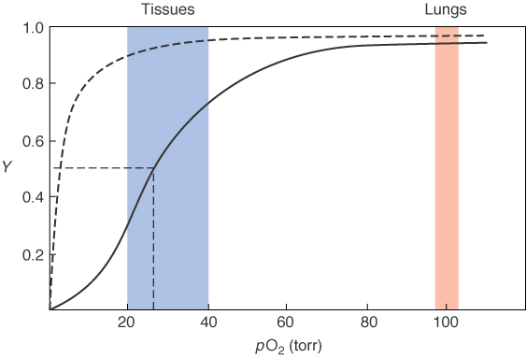
Part III. Amino Acids (30 pts)
Please label them with their full name, three-letter abbreviation and one–letter abbreviation.

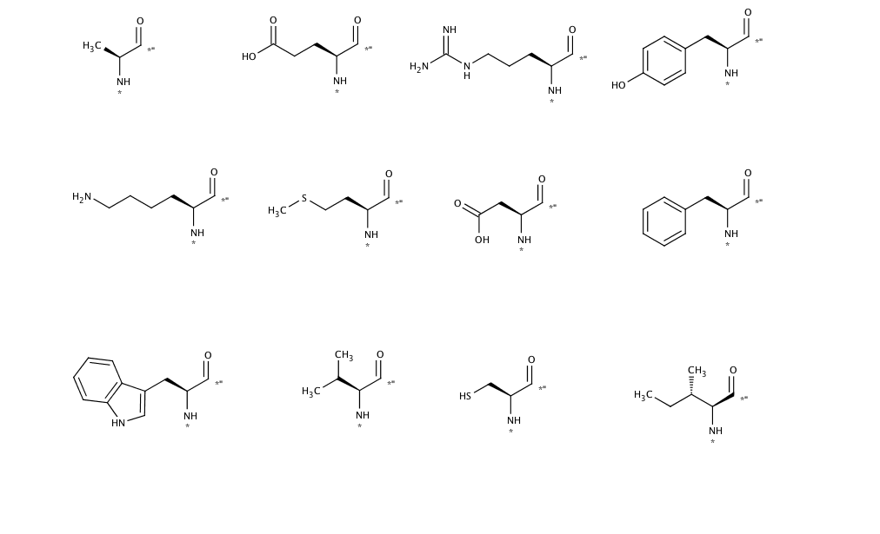
Part IV: Net Charge of Peptides (10 pts)

Consider the following peptide:

Met – His – Gly – Ser – Lys – Asp

Use the following table and determine the net charge on the protein at:
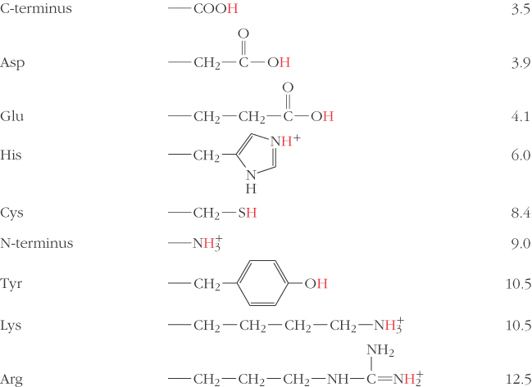

pH = 2

pH = 7

p = 12

