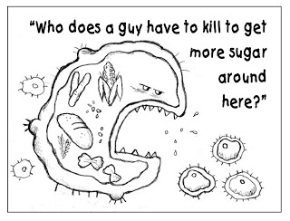

- The first reaction in glycolysis that results in the formation of an energy-rich compound (i.e., a compound whose hydrolysis has a highly negative ΔG’°) is catalyzed by:
  - glyceraldehyde 3-phosphate dehydrogenase.
  - phosphofructokinase-1.
  - phosphoglycerate kinase.
  - hexokinase.
  - triose phosphate isomerase.
- Which of the following coenzymes is required by E₁ of the pyruvate dehydrogenase complex for catalytic activity?
  - TPP
  - lipoic acid
  - FAD
  - NAD⁺
  - None of the above
- In alcoholic fermentation, acetaldehyde is produced by
  - the decarboxylation of pyruvate
  - the carboxylation of pyruvate
  - the decarboxylation of lactate
  - the carboxylation of lactate
  - None of the above

- Which of the following is required for the conversion of succinate to fumarate in the citric acid cycle?
- FAD
- GDP
- NADH₂
- TPP
- CoQ

- Which reaction of the citrate acid cycle is most similar to the reaction catalyzed by pyruvate dehydrogenase complex?
  - succinyl-CoA
  - citrate to isocitrate
  - fumerate to malate
  - malate to oxaloacetate
  - α-ketoglutarate to succinyl-CoA

- What is the net reaction of pyruvate dehydrogenase?
  - pyruvate + CoA + NADH acetyl-CoA + CO₂ + NAD⁺
  - pyruvate + CoA + NAD⁺ acetyl-CoA + CO₂ + NADH
  - pyruvate + CoA + FAD acetyl-CoA + CO₂ + FADH₂
  - acetyl-CoA + CoA + NAD⁺ pyruvate + CO₂ + NADH
  - none of the above
Short Answer
- In the conversion of glucose to pyruvate via glycolysis, all of the following enzymes participate. Indicate the order in which they function by numbering them one through ten.
___ phosphofructokinase
___ triose phosphate isomerase
___ glyceraldehyde 3-phosphate dehydrogenase
___ phosphoglycerate kinase
___ hexokinase
___ phosphoglucose isomerase
___ enolase
___ phosphoglycerate mutase
___ aldolase
___ pyruvate kinase

Name the two enzymes that catalyze a reaction in which ATP is consumed? __________________________________________

Which enzyme catalyzes a reaction in which NADH is produced? _____________________

Which enzyme converts G3P into 1,3 BPG? __________________________

Name two enzyme reactions from glycolysis that operate at ΔG ≈ 0 _______________________
- Three reactions in glycolysis operate far from equilibrium and are potential sites for major flux control. List the three enzymes and discuss why each enzyme is or is not the RDS of glycolysis.

- Show the steps of the citric acid cycle from succinyl-CoA to oxaloacetate only. For each step, show structures of substrate and product, name the enzyme responsible, and show where cofactors participate

- (6 pts) Match the names with the following:
Name | Figure letter
NAD⁺ | B
FAD | D
CoA | F
ATP | C
TPP | A
Lipoic Acid | E
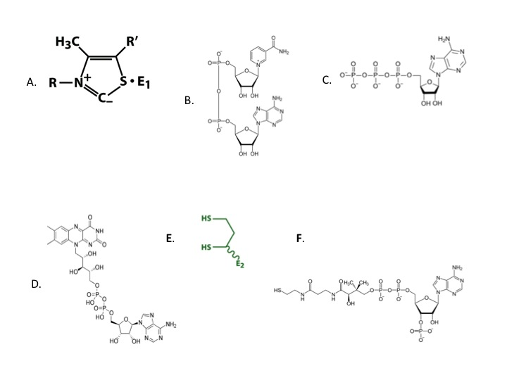
Part III: Short essay

- Describe the enzymes, cofactors, intermediates, and products the pyruvate dehydrogenase complex.
- Succinyl-CoA inhibits both citrate synthase and α-ketogluterate dehydrogenase. How is succinyl-CoA able to inhibit both enzymes?
- ADP stimulates the activity of phosphofructokinase (PFK) yet it is a product of the reaction, not a reactant. Explain this apparently contradictory regulatory strategy.

