Practice Test Exam 2

- For the reaction A B , what is the effect of adding an enzyme on the overall standard free energy change of the reaction (ΔG)?
- No change
- Increase in the free energy
- Decrease in the free energy
- What is free energy – nothing is for free!

- Which of the following amino acid residues would not provide a side chain for acid-base catalysis?
A) leucine
B) arginine
C) lysine
D) aspartic acid
E) histidine

- Which of the following statements about a plot of V₀ vs. [S] for an enzyme that follows Michaelis-Menten kinetics is false?
- As [S] increases, the initial velocity of reaction V₀ also increases.
- At very high [S], the velocity curve becomes a horizontal line that intersects the y-axis at K_{m}.
- K_{m} is the [S] at which V₀ = 1/2 V_{max}.
- The shape of the curve is a hyperbola.

- In this type of inhibition, the inhibitor can only bind to the ES complex to form an ESI complex.
- Competitive
- Mixed
- Transition state
- Irreversible
- None of the above

- Which of the following is NOT an assumption of the Michaelis - Menten equation?
- k_{cat} = k₂
- [S] >> [E]
- [E]_{T} = [ES] + [E]
- k₋₁= k₁
- steady state

- The Lineweaver-Burk plot is used to:
- determine the K_{eq} for an enzymatic reaction.
- extrapolate for the value of reaction rate at infinite enzyme concentration.
- illustrate the effect of temperature on an enzymatic reaction.
- solve, graphically, for the rate of an enzymatic reaction at infinite substrate concentration.
- solve, graphically, for the ratio of products to reactants for any starting substrate concentration.

- (2 pts) The proper name of this glucose is:

  - β-D-glucose
  - α-D-glucose

- Which of the sugars shown in the figure are l sugars?
A) A and B
B) B and C
C) C and D
D) A and D
E) None of the above
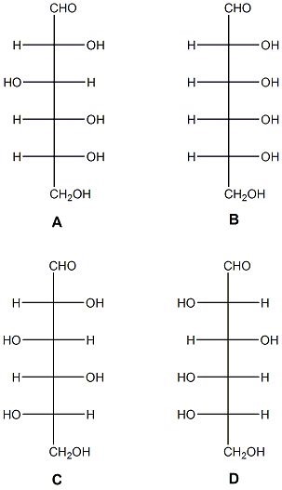

- Which sugar is the enantiomer of sugar A?
A) B
B) C
C) D
D) B and D
E) none of the above

- Which two sugars shown in the figure are epimers?
A) A and B
B) B and C
C) C and D
D) A and D
E) None of the above

- Which of the following polysaccharides cannot be digested by mammalian salivary, gastric, or pancreatic enzymes?
A) cellulose
B) amylopectin
C) amylose
D) glycogen
E) starch

- Chymotrypsin, a serine protease, preferentially cleaves a peptide bond adjoining a bulky non-polar side chain. This is because chymotrypsin's specificity pocket:
A) contains a sulfhydryl group that forms a disulfide bond with the substrate.
B) is lined with small hydrophobic side chains, leaving considerable room in the nonpolar pocket.
C) contains a negative charge.
D) is mostly filled with large side chains.
E) contains a positive charge.

- Which of the following sugars contains a β-1,4-linkage?

A) Cellulose
B) Glucose
C) Amylose
D) Sucrose
E) Maltose

- In the Lineweaver-Burk double reciprocal plot the horizontal intercept is equal to _________.

A) 1/[S]
B) 1/V
C) K_{m}/V_{max}
D) 1/V_{max}
E) –1/K_{m}

- In competitive inhibition, increasing the concentration of substrate:

A) Decreases the overall rate of the reaction
B) Increases the overall rate of the reaction
C) Is without effect
D) The observed effect depends on the inhibitor
E) Competitive inhibitors do not affect the rate of the reaction

Short Answer:

- Given the graph below, what the assumptions of the Michaelis-Menten equation and explain how those are being demonstrated in the graph.

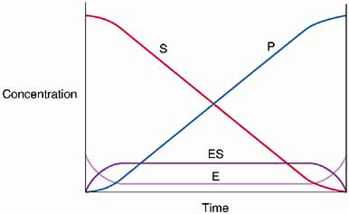

- How are the types of inhibition kinetically distinguishable?

- How can an enzyme promote the production of product from reactants? Please answer this question using thermodynamic arguments.

- The enzyme hexokinase acts on both glucose and fructose. The K_{M} and V_{max} values are given in the table. Using these data, compare and contrast the interaction of hexokinase with both of these substrates.

Substrate | K_{M} (M) | V_{MAX} (relative)
Glucose | 1.0 X 10⁻⁴ | 1.0
Fructose | 7.0 X 10⁻⁴ | 1.8

- Describe the chymotrypsin mechanism especially discussing the role of the catalytic triad and the tetrahedral intermediate.
Answers
- A
- A
- B
- C
- D
- D
- A
- C
- C
- A
- A
- B
- A
- E
- B

